million voices

Executive SUMMARY

2024 new faith voters

The Problem. Eligible voters fail to register and turn out to vote in significant numbers. Education in a non-partisan form is the #1 determining factor in election participation for 75% of voters. Essentially, this pattern is found equally among faith-based and conservative-leaning citizens.

The Opportunity. Using advanced data-modeled technological communication strategies, we can identify, educate, motivate, and turn out significant numbers of faith-based and freedom-leaning citizens. Our methods are scalable and meticulously measured to accurately demonstrate a significant return on investment.

The Methodology. We built data models measuring actual church members. By using sophisticated technology to identify faith-based and freedom-leaning voters, we are enabled to:
- Distinguish voter issues and voter history (non-registered, registered non-voting; low propensity; mid propensity; high propensity) and change the CTA for each.
- Increase voter education, registration, and turnout.
- Increase voter information pertinent for all faith and freedom voters.
- Significantly increase turnout in low-propensity voters.

The Data & Technology. We append voter history to new voters as they opt-in or pledge to vote and educate them accordingly for increased turn-out. We hyper-target modeled voters to every device within individual homes. We obtain pledges for action, then inform with church-approved and footnoted voter guides delivered on mobile devices. Voters can opt-in for tools, and then click to share the guide to educate their friends. We built a nationwide tool of 7,383 state representatives connected to voters in their prospective districts on the issues most cared about. We are building grassroots software that trains voters to legally ballot gather and ballot chase.

Our Empirical Results. We measure our results down to the voter by comparing prior voting status or history and new behavior after education and mobilization. See After Action Review Measurements.

The Organizational Advantage. Our organization is recognized by the IRS as an association of churches that exempts us from public reporting of contributions typically required and increasingly used to harass Christians and conservatives. Our donor names are never filed with the IRS or any government entity, protecting our donors from harassment when tax returns are leaked. Our voter guides and methods of operation are strictly compliant with laws for non-profit, tax-deductible organizations, and validated by nationally recognized legal organizations.

The Need. We can mobilize faith voters to measurably increase their turnout in upcoming elections. 100% of all donations go to reach voters as our administrative overhead is financially supported. With proper funding, we can reach over 75 million faith voters to engage in the presidential election as well as the most critical 15 senate elections and 50 congressional districts. Every dollar will be matched, sending 10 faith voters voter guides on their phones in key states.

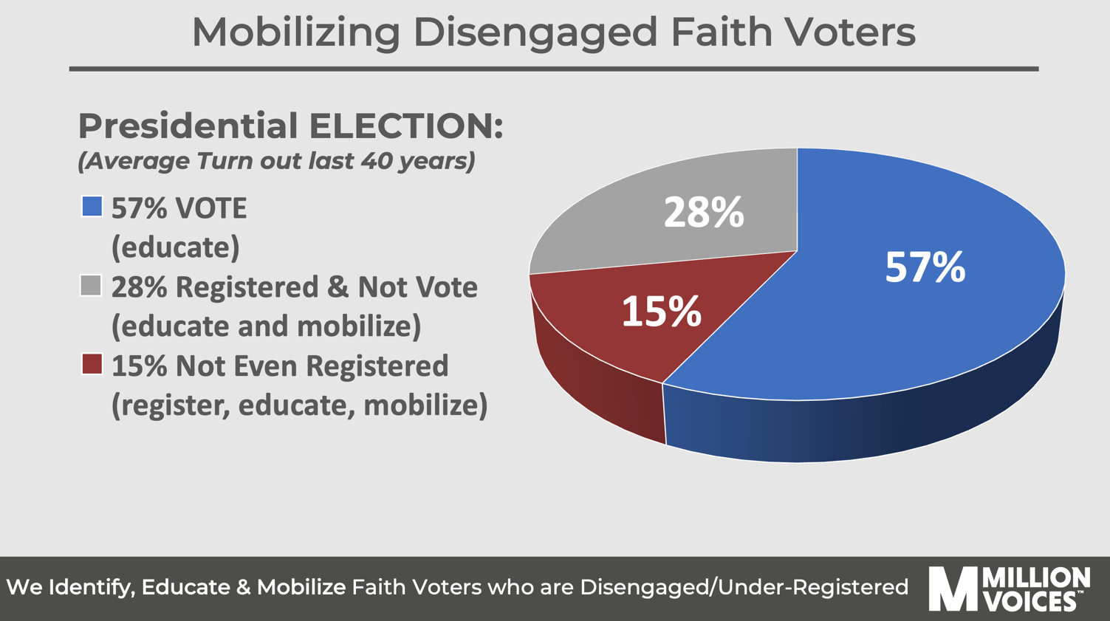

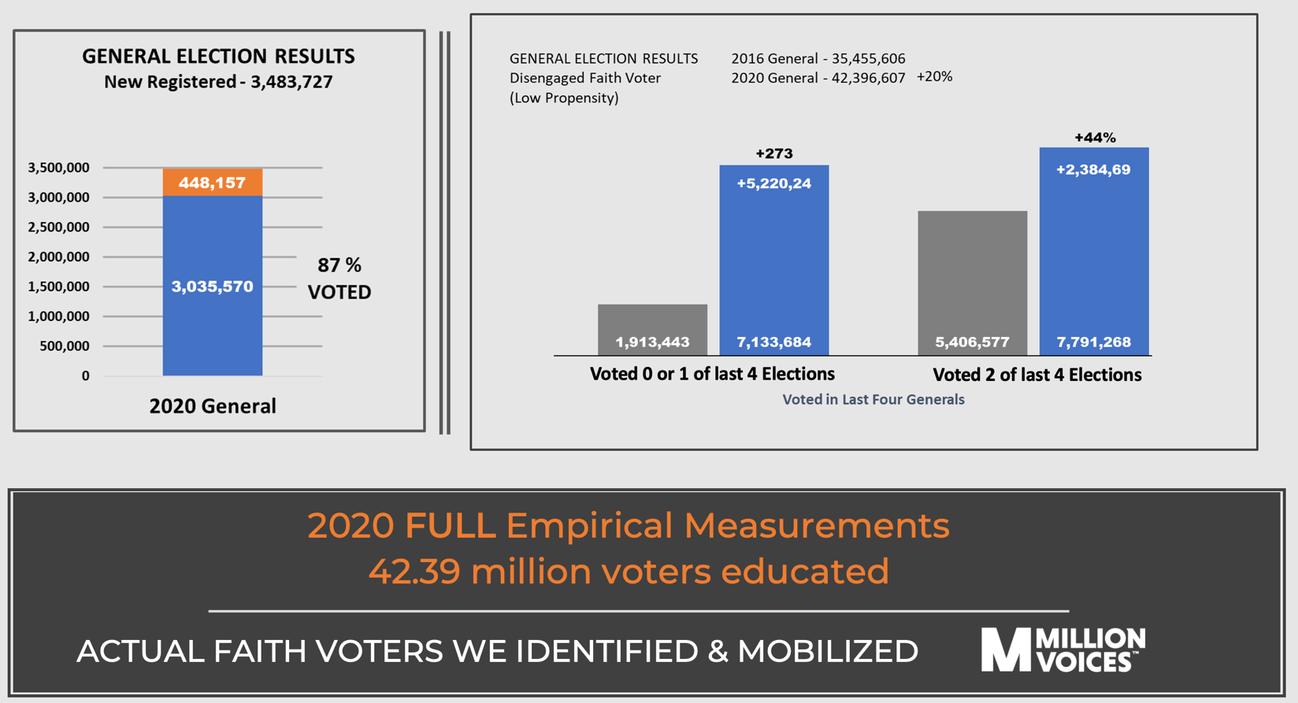

42.3+ MILLION FAITH VOTERS received FREE church-approved, nonpartisan voter guides on their phones in 2020,
and voted in 17 critical states.

